CITY OF RAWLINS
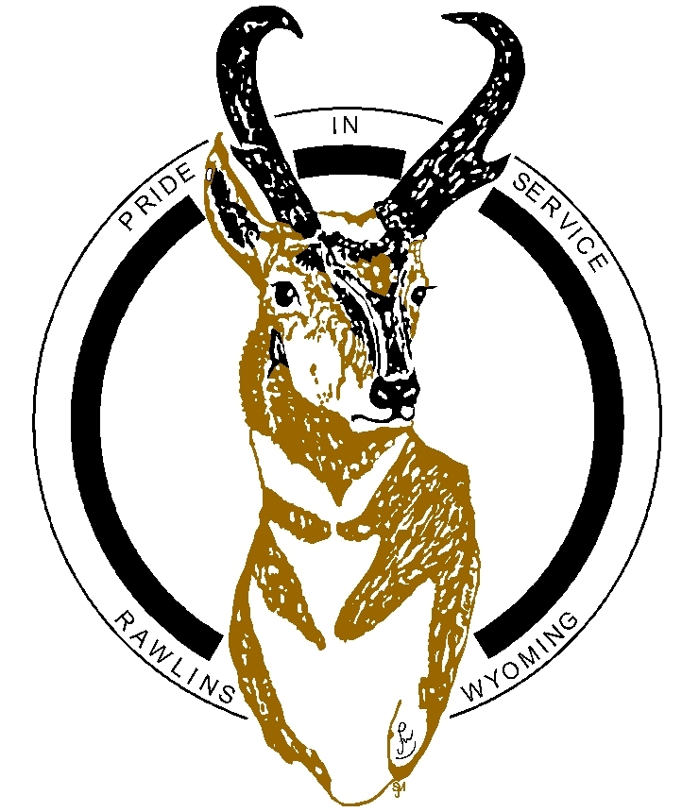
SPECIAL EVENTS APPLICATION

Relevant to the use of city property, including location, storage of vehicles, equipment, and crowd control.

Applicant hereby agrees to not have any participants from a vehicle throw candy in a parade.

NAME OF EVENT:
Name of Applicant: | Organization:
Address: | Address:
City/State/Zip | City/State/Zip
Phone Number:  Cell Number:  Email Address: | Business Phone Number:  Fax:  Email Address:
Begin Date: | End Date:
Start Time: | End Time:

Briefly describe your proposed event: (Use an additional sheet if necessary.)

Specific location of event:
Please attach a daily Schedule of Event(s) tentatively planned for each activity and location, if applicable.

Approximate number of anticipated participants: _________________________________

Approximate number of event /support staff: _____________________________________

Number of vehicles/parking requirements: ________________________________________

Location and Description of city property to be used: _____________________________

Coordination with City of Rawlins Departments:

City Clerk | 307-328-4500
Fire Department | 307-328-4596
Police Department | 307-328-4531
Public Works | 307-328-4599
Rawlins DDA/Main Street | 307-328-2099
Recreation Services | 307-328-4573

- Special Services requested from Fire Department: (See Rate Sheet)

- Special Services requested from Police Department: (See Rate Sheet)

Please describe in detail your security plans:

- Special Services requested from Public Works Department: (See Rate Sheet)

- Special Services requested from Rawlins DDA/Main Street: (See Rate Sheet)

- Special Services requested from Recreation Services: (See Rate Sheet)

- Please describe in detail your traffic control/parking plans:

- Please describe in detail your garbage containment and removal plans and port-a-potty plans: (Identify all locations on a site map located on the next page.)

- Alcoholic Beverages (Dispensing of Alcoholic Beverages requires additional permits and nothing herein is intended to relieve you from the responsibility of obtaining these additional permits or complying with additional or more stringent requirements.)
- Give a description of the dispensing area and where it is located (e.g. 10’ x 12’ roped area in the NW corner of the Jeffrey Center parking lot), the type of license to be used, procedures for proper identification for purchases, and Supervisor of operation:

NOTICE: You are financially responsible for your acts of negligence and may be financially responsible for the negligent acts of others involved in this event. You are encouraged to obtain insurance for this activity. You and participants in the activity are not insured by the City of Rawlins*.
*The City of Rawlins is a governmental entity subject to the Wyoming Governmental Claims Act, the Wyoming Constitution, Wyoming Statutes and a member of the Local Government Liability Pool. As such the City may not indemnify another or add as an additional insured any other person or entity. The City of Rawlins is insured for only the negligence of its employees up to the maximum claim allowable by law against the City. The City does not waive their sovereign immunity by entering into this agreement, and the City fully retains all immunities and defenses provided by law with respect to any action based on or occurring as a result of this event.

Check List:
- Your permit must be displayed for easy public view in the area the alcoholic beverages will be dispensed.
- You and members of your organization take the responsibility of making certain no one under the age of 21 years is allowed in the dispensing area defined above. If you are not dispensing from a stand, simply rope off an area, call it your dispensing area, and keep minors outside the rope.
- The Police Department is notified of your event. If you have a problem, please contact them immediately. If you even suspect a minor is in possession of any alcoholic beverage, contact a Police Officer. They are most happy to assist you in any way they can.

- Food Services: For food service requirements, contact Wyoming Department of Agriculture, Consumer Health Services Specialist, Mykel A Murry, (307) 324-3220 or mykel.murry@wyo.gov.

- Other request for service:

Other Agencies or groups contacted? (If Applicable)
AGENCY OR GROUP | Circle Appropriately | AGENCY OR GROUP | Circle Appropriately
Rawlins-Carbon County Chamber of Commerce | Yes or No | Carbon County Commissioners | Yes or No
Carbon County Fairgrounds | Yes or No | Carbon County Jeffrey Center | Yes or No
Carbon County Sheriff’s Office | Yes or No | Carbon County School District One | Yes or No
Rawlins DDA/Main Street | Yes or No | Union Pacific Railroad | Yes or No
Wyoming Game & Fish | Yes or No | WY Department of Transportation | Yes or No
Utility Providers:  City of Rawlins (Water)  Rocky Mountain Power (Electric)  Source Gas (Natural Gas) | Yes or No  Yes or No  Yes or No | List Any Other Businesses, Organizations or Neighbors Contac:

Use this space for a Site Map:

STREET CLOSURE MAP

Event: | Organization:

Date: | Street Closure  Time: | Parade/Event Start  Time:

N

Events Contact Information:
Manager in Charge: _______________________________________________________________

Home Phone: | Cell Phone:

Alternate Manager: ________________________________________________________________

Home Phone: | Cell Phone:

INSURANCE INFORMATION
NOTICE: You are financially responsible for your acts of negligence and may be financially responsible for the negligent acts of others involved in this event. You are encouraged to obtain insurance for this activity. You and participants in the activity are not insured by the City of Rawlins*.
*The City of Rawlins is a governmental entity subject to the Wyoming Governmental Claims Act, the Wyoming Constitution, Wyoming Statutes and a member of the Local Government Liability Pool. As such the City may not indemnify another or add as an additional insured any other person or entity. The City of Rawlins is insured for only the negligence of its employees up to the maximum claim allowable by law against the City. The City does not waive their sovereign immunity by entering into this agreement, and the City fully retains all immunities and defenses provided by law with respect to any action based on or occurring as a result of this event.

Agreement to the City of Rawlins Special Events Conditions:

Applicant hereby agrees to not have any participants from a vehicle throw candy in a parade.

- Applicant hereby agrees to comply with the City of Rawlins Special Events conditions attached hereto and incorporated herein by this reference. Upon signing this application, the applicant agrees not to violate any State or City codes in the presentation of the requested special event.

- In consideration for approval to conduct activity as requested, the applicant agrees to indemnify, defend and hold harmless up to the City’s liability pursuant to the Wyoming Governmental Claims Act the City of Rawlins, its officers, agents, employees and volunteers from damage to property and for injury or death of any person and from all liability claims, actions or judgments which may arise from this activity.

- Applicant also agrees to obtain valid safe or hold harmless agreements from all participants in its activity, protecting the City of Rawlins from all losses arising out of its activity, including damages of any kind or nature.

- Applicant is to be financially responsible for damage to city property and other cost as described in Paragraph 4, of the Special Events Condition if no bond is posted.

Applicant Signature Date

